TMT/ Gujarat/S0699/2026 09-03-2026

To
Saiyed Alamuddin M

Global Construction (GST verified by IndiaMART)
Click to call: +91-9925654343 (verified)
Email: globalconstruction110@gmail.com (verified)
Building No-A13 Bypass Road, Bharuch - 392001, Gujarat, India

Dear Sir,

Sub: - Supply of Three Roller Plate bending machine

We thank you for your enquiry regarding Plate Bending machine for MS plate width 2500 thickness of 16 mm. We are glad to inform you that we would be in a position to do the required equipment with the following specifications and description of the machine along with our terms and conditions.

S No | Description of the unit | Offer
1. | Supply Three Roller Plate Bending machine for 2500 X 16 MM along electrical | Rs 8,75,000/- (Rupees Eight Lakhs Seventy Thousand only)

Specifications of the equipment:

1) Maximum width of Rolling : 2500 MM

2) Maximum thickness of Rolling : 16 MM

3) Top Roll diameter : 280 MM

4) Bottom Roller Diameter : 265 MM

5) Minimum Rolling Diameter : 460 MM

6) Rolling speed : 3.0 rpm.

7) Maximum yield limit of the plate : 245 Mpa.

8) Total power : 28.5 HP
Main drive : 15 HP
Screw drive: 5 HP - 2 nos
Door opening : 3 HP
Oil pump :.5 HP

GENERAL TERMS & CONDITIONS:

- Price quoted per unit ex-work. Hyderabad.
- Following charges are additional to your account.
- Freight Charge : As actual to be borne by you.
- Sales Tax : 18% Extra as applicable
- Packing charge : As actual to be borne by you.
- Insurance : As actual to be borne by you.
- Payment : 50% advance along with order balance before delivery but after inspection at our works.
- Delivery : Within 1 months from date of advance received
- Validity : One month from the date of submission.
- Inspection : Inspection at our works prior to dispatch.
- Warranty : The machine is warranted for a period of 12 months from the date of dispatch against any manufacturing defects/ faulty material or bad workmanship of any part or component but not against any kind of abnormal or improper use of machine. Defective part or component will be replaced or repaired free of cost. Electrical components are outside the scope of this warranty.
- Commissioning : Erection & commissioning done by you, but required technical support & guidance provide by us at additional cost.

NOTE:
- Oil is not in scope of our supply.
- Raw material for trial is to be arranged by you at your cost.

We are sure you will find our offer in line with your requirements. Should you require any further clarification please contact T.SIVARAMAKRISHNA 9246221106/9849207176 emil: techno9246221106@gmail.com

Thanking you and assuring you of our best services.

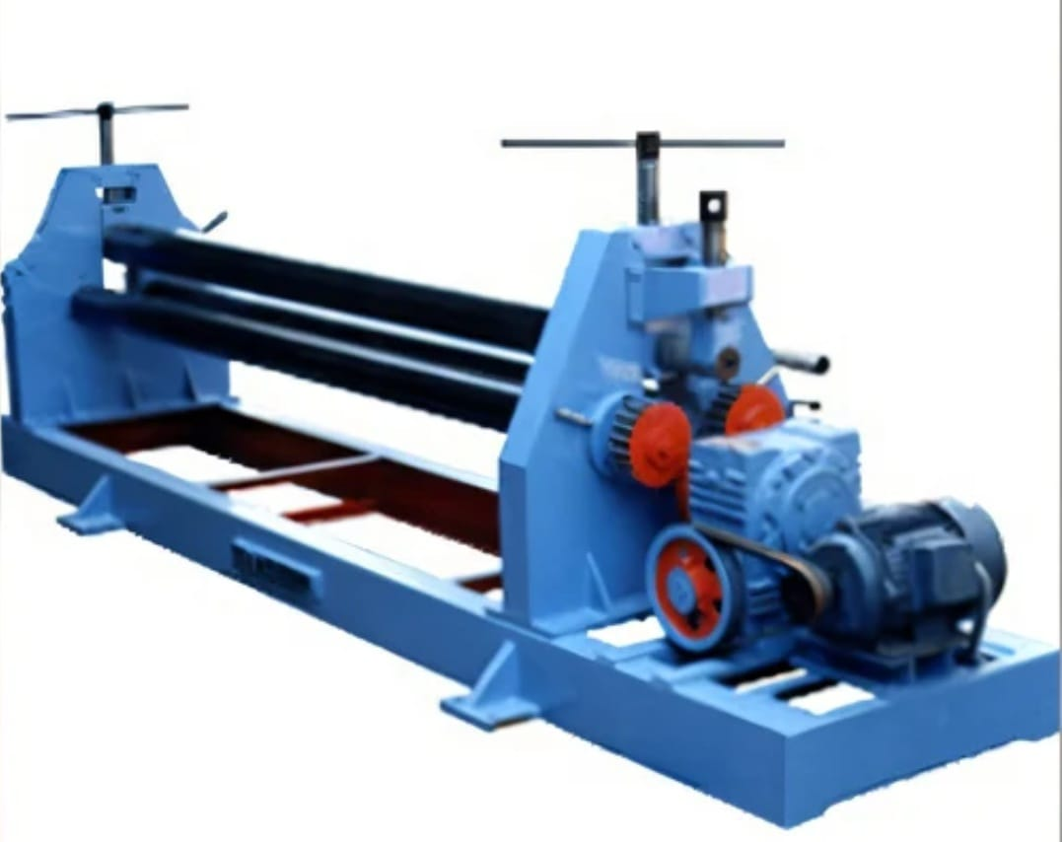

For TECHNO MACHINE TOOLS

( T. SIVARAMAKRISHNA)

